Dr. N. Shantha Naik 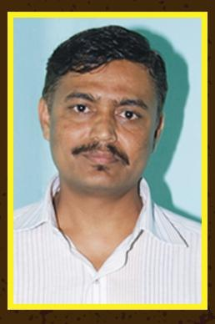
MA PhD
Professor
Email: akampan2000@gmail.com
Dr. N.Shantha Naik. Taught at the undergraduate level at Maharaja’s College, University Of Mysore for ten years and also as a experience of working at AIR Karwar. Joined Vijayanagara Sri Krishna Devaraya University Ballari in 2012, as Associate Professor. Specialized in linguistics and American literature and also literature in Indian English for his PhD from KarnatakaUniversity,Dharward.A comparative Study of the Novels of ShashiDeshpande and M.K. Indira:A Social and Cultural Perspectives.2009,Teaching English Language through literature,2010.Women psyche in world women novel list2012.Dalit Literature our response2012,Interference of Regional Languages Phonology inIndian English Learners,2012Retrospection and Introspection of Dalit Literature 2013. Approach and re approach to English literature, 2017. Worked as NSS Co- Coordinator, Dean Student Welfare, Cultural Co- Coordinator, Director Prasaranga, Director Sports. He worked as Chairman of second language English Text Book Review Committee, for Karnataka Text Book Society. He completed major research project funded by ICSSR, New Delhi. He is also a good translator and creative writer. His novel ‘Goarmati-An Un Ending Journey’ and the play ‘The Banjara Warrior’ also published in English language.

