Department of Library and Information Science 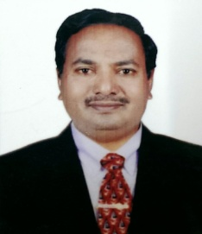
Dr. Gavisiddappa Anandhalli is presently working as a Associate Professor and Chairman of the Department of Library and Information Science and (I/C) Librarian, Vijayanagara Sri Krishnadevaraya University, Bellari, In addition to this he also worked as a Associate Professor and Chairman in the Department of Library and Information Science and (I/C) Librarian at Karnataka State Akkamahadevi Women’s University, Vijayapura, He also worked at Proudhadevaraya Institute of Technology, Hospete as Chief Librarian for more than 9 years. He holds Bachelor Degree in Science and Master Degree in Library and Information Science from Kuvempu University, Shivamogga. He received his M. Phil and Ph. D degree from Gulbarga University, Gulbarga. And he has also cleared UGC-NET/JRF examination in the year 1998. He has over 12 years of teaching, research experience and 10 years as a LIS professional experience. He really strives hard for the development of library profession and automation of library activities. He has successfully conducted several organizational assignments. He has published good number of research papers both in National and International Refereed Journals. User Study, ICT Skill, Information Literacy and Digital Library, Research Methodology, Statistics and Scientometrics are the important areas of his specialized research interest. He has published over 60 papers, 2 books and 2 Edited books and organized about 5 seminars/ workshops. He visited Japan, Osaka to present paper on “Internet Literacy Among Research Scholars in India” in the year 2015 and also International Committee member for International Conference on LIS June 2016 Kyoto, Japan. He received “Best Teacher Award” from Karnataka State SC/ST Library Professional, Gulbarga University, Kalaburgi.
He has guided 5 Ph.D and 4 M. Phil students successfully. He has implemented several innovative practices in the library such as Complete Automation of Library, Anti-plagiarism, Earn and Learn Scheme and Best Library User Award etc.

(Dr. Gavisiddappa Anandhalli)

