3.JAVA APPLETS
Applet is a special type of program that is embedded in the webpage to generate the dynamic content. It runs inside the browser and works at client side.

Advantages of Applet
There are many advantages of applet. They are as follows:
- It works at client side so less response time.
- Secured
- It can be executed by browsers running under many plateforms, including Linux, Windows, Mac Os etc.
Java program has two types. They are:
- 1. Application Program (Stand-alone application)
- 2. Applets Program.
- Stand-alone applications are those java programs that can be developed and executed on a stand-alone local computer
- Applet Programs are small java programs developed for internet applications. Applets are embedded in HTML documents. Applet programs can be run using the applet viewer or web browser.

Difference between Stand alone application and Applet
Feature | Application | Applet
main() method | Present | Not present
Execution | Requires JRE | Requires a browser like Chrome
Nature | Called as stand-alone application as application can be executed from command prompt | Requires some third party tool help like a browser to execute
Restrictions | Can access any data or software available on the system | cannot access any thing on the system except browser’s services
Security | Does not require any security | Requires highest security for the system as they are untrusted

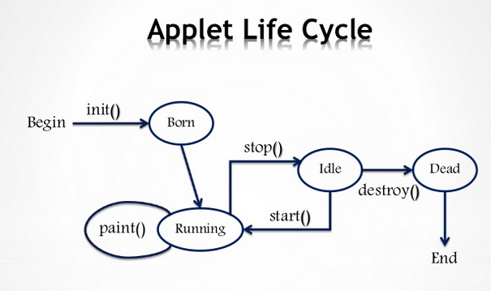
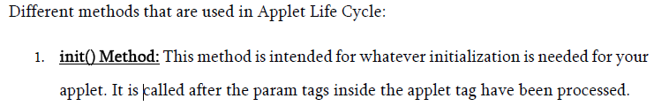
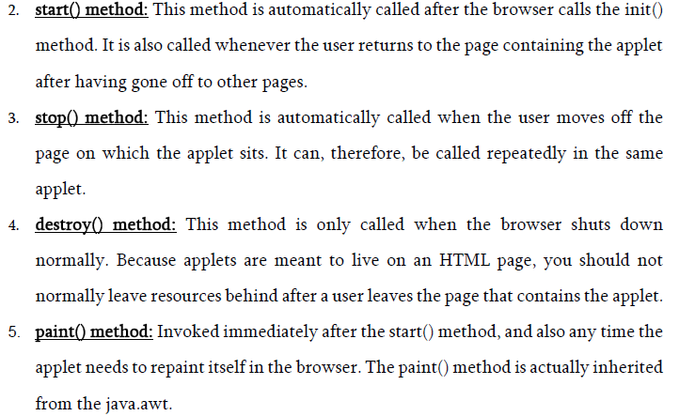

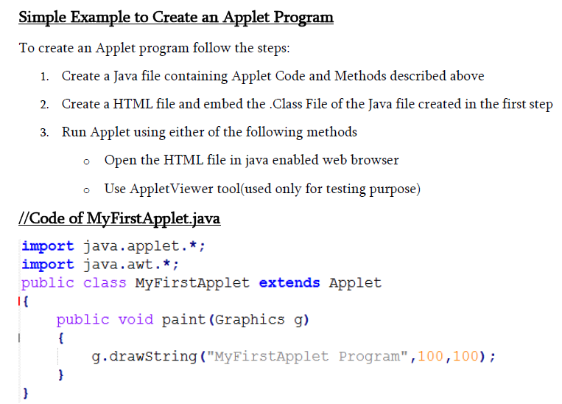
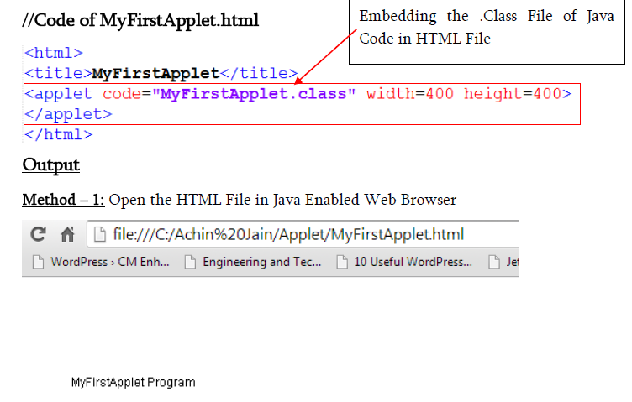
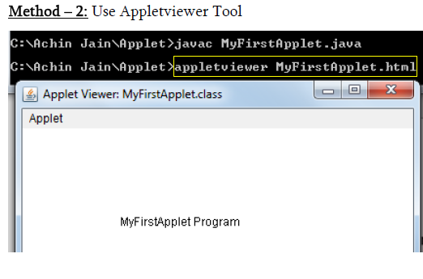

Parameter in Applet
We can get any information from the HTML file as a parameter. For this purpose, Applet class provides a method named getParameter(). Syntax:
public String getParameter(String parameterName)

Example of using parameter in Applet:

import java.applet.Applet;
import java.awt.Graphics;

public class UseParam extends Applet{

public void paint(Graphics g){
String str=getParameter("msg");
g.drawString(str,50, 50);
}

}

myapplet.html
<html>
<body>
<applet code="UseParam.class" width="300" height="300">
<param name="msg" value="Welcome to applet">
</applet>
</body>
</html>

Displaying Graphics in Applet
java.awt.Graphics class provides many methods for graphics programming.

Commonly used methods of Graphics class:
- public abstract void drawString(String str, int x, int y): is used to draw the specified string.
- public void drawRect(int x, int y, int width, int height): draws a rectangle with the specified width and height.
- public abstract void fillRect(int x, int y, int width, int height): is used to fill rectangle with the default color and specified width and height.
- public abstract void drawOval(int x, int y, int width, int height): is used to draw oval with the specified width and height.
- public abstract void fillOval(int x, int y, int width, int height): is used to fill oval with the default color and specified width and height.
- public abstract void drawLine(int x1, int y1, int x2, int y2): is used to draw line between the points(x1, y1) and (x2, y2).
- public abstract boolean drawImage(Image img, int x, int y, ImageObserver observer): is used draw the specified image.
- public abstract void drawArc(int x, int y, int width, int height, int startAngle, int arcAngle): is used draw a circular or elliptical arc.
- public abstract void fillArc(int x, int y, int width, int height, int startAngle, int arcAngle): is used to fill a circular or elliptical arc.
- public abstract void setColor(Color c): is used to set the graphics current color to the specified color.
- public abstract void setFont(Font font): is used to set the graphics current font to the specified font.

Example of Graphics in applet:

import java.applet.Applet;
import java.awt.*;

public class GraphicsDemo extends Applet{

public void paint(Graphics g){
g.setColor(Color.red);
g.drawString("Welcome",50, 50);
g.drawLine(20,30,20,300);
g.drawRect(70,100,30,30);
g.fillRect(170,100,30,30);
g.drawOval(70,200,30,30);

g.setColor(Color.pink);
g.fillOval(170,200,30,30);
g.drawArc(90,150,30,30,30,270);
g.fillArc(270,150,30,30,0,180);
}
}

myapplet.html
<html>
<body>
<applet code="GraphicsDemo.class" width="300" height="300">
</applet>
</body>
</html>

Animation in Applet
Applet is mostly used in games and animation. For this purpose image is required to be moved.

Example of animation in applet:
import java.awt.*;
import java.applet.*;
public class AnimationExample extends Applet {

Image picture;

public void init() {
picture =getImage(getDocumentBase(),"bike_1.gif");
}

public void paint(Graphics g) {
for(int i=0;i<500;i++){
g.drawImage(picture, i,30, this);

try{Thread.sleep(100);}catch(Exception e){}
}
}
}
In the above example, drawImage() method of Graphics class is used to display the image. The 4th argument of drawImage() method of is ImageObserver object. The Component class implements ImageObserver interface. So current class object would also be treated as ImageObserver because Applet class indirectly extends the Component class.

myapplet.html
<html>
<body>
<applet code="DisplayImage.class" width="300" height="300">
</applet>
</body>
</html>

